South Metropolitan TAFE

Munster Campus

Applied Engineering

AGV Mecanum Platform

P

Advanced Diploma in Engineering - Mechanical

Author

Student ID

Date

## Abstract

*In this section you are to write a brief summary of the report. The abstract should be:*

* *An appropriate length.*
* *A complete summary of key information.*
* *Informative, not descriptive, in form.*
* *Impersonal in tone.*
* *Written with connected prose.*

*Remove ALL italicised instructional text found in this document prior to submitting your assignment.*

Table of Contents

Abstract 2

Introduction 4

AGV Platforms 4

Design Concept 4

Problems associated with the design 4

Design Components & Material Selection 4

Mecanum Wheel 5

Frame 5

Lifting Mechanisms 5

Drive System 5

Control System 5

Calculations 6

Costings 6

Discussion and Conclusion 6

Recommendations 6

References 6

List of Figures 6

List of Tables 6

Appendix 6

## Introduction

*This section must address the following criteria:*

* *Relating topic to wider field.*
* *Necessary background information.*
* *Purpose of report.*
* *Scope of report.*
* *Explanation of arrangement of report.*
* *Sections.*

## AGV Platforms

*This section should give an explanation of what AGV platforms are, how they operate, their uses, how they’re powered, lift capacities, price ranges, etc.*

## Design Concept

*This section should give an outline of the criteria from which the design was based.*

*Eg. lift capacity, speed limits, overall size, standards, ip65, etc. Be thorough in this section.*

## Problems associated with the design

*In this section, discuss any issues or problems that were associated with the initial design and who they were resolved.*

An issue associated with the design was the choice of the initial lifting system. Initially a pneumatic lifting system was chosen, this consisted of an airbag with an on-board compressor. This options was chosen for its ease in installation and maintenance, its high capacity and cost compared to other systems. The airbag recommended by the supplier for our purpose is shown in appendix. On further discussion with Michael Wernik a price of $397 for the airbag and $348 for the compressor. There is no official quote from this supplier as it was received over the phone, but the email correspondence is shown in appendix

The issue that arose with this system was learning from the supplier that an on board receiver would be require as the compressor would not be capable of sustaining the lift, as the volume of the airbag at 100psi and full lifting height is 4 litres, a receiver with an 8 litre capacity was required, as the compressor could only be used for filling the receiver. This was an issue as the client scope was to fit through a standard door frame, meaning the maximum length and width could not exceed 1000mm x 800. The Supplier sent through receivers shown in appendix. On further inspection of this it was found that it was not possible to fit a receiver and keep within the scope size limits. For this all options were exhausted, one option was to use the SHS as a receiver but this was deemed unfeasible due to the cost of pressure testing and the complex welding involved. This then resulted in a redesign of the lifting mechanism, as the implementation cost of the pneumatic lifting mechanism outweighed the cost of a redesign.

## Design Components & Material Selection

*In this section, discuss how you went about the design from initial brain storming, sketching, etc. through to the finished part/assembly. Be sure to include any sketches, images and notes that are relevant to the part. Discus any events that may have had an impact on the final design outcome, eg. High cost of initial design, availability of material, etc. Be sure to include your material selection criteria.*

*This section should be a compilation of individual work, that is, each student should only write about the parts they were involved with and any other team member that may have contributed to your design. Be sure to include any relevant specifications such as weight, dimensions, power, etc.*

### Mecanum Wheel

*Rollers, Cheek Plates, Hub, Bearings, Axles, Urethane..*

### Rollers

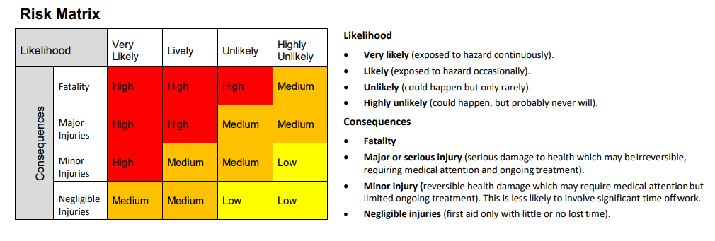One of the first tasks on this project was to design the Mecanum Wheel, one major part of this design was the individual rollers as this can have a huge effect on the stability of the vehicle. If the mecanum wheel is not a complete total circle it can cause a rough and bouncy drive. Due to the fact that in the initial scope the vehicle was to lift 500kg and then increase to 1000kg, the even drive of the vehicle was a major concern as the instability of the load would pose a risk to pedestrians. A Risk matrix in figure was used to analyse the risk of an uneven drive, form the matrix below it was deemed the risk of an uneven drive was deemed as a medium risk due to the maximum lifting height being a maximum of 80mm, to ensure safety the wheel was designed to minimise this risk.

Figure 1.1 Risk Matrix 1

Initially using a standard ellipse in the design of the roller incurred problems as the gap in the roller was deemed to be to large and would cause issues with the stability of the vehicle. Through further research a method shown in appendix,2 with some trial calculations shown in the calculation section this method was inconclusive. Another method trialled was the use of AutoCAD and geometry to calculate the angel curvature of the ellipse and give a full shape of the roller, this method is shown in appendix. This method proved most successful and was the chosen design strategy as it gave minimal spacing between rollers. Figure 1.3 shows the assembled mecanum wheel.

### 

Figure 1.3 Mecanum Wheel assembly

One factor that was required by the client was to keep the number of rollers to a minimum of 6, this was required to keep manufacturing costs to a minimum. This impacted the design of the roller as the size and shape of the roller had an effect on the number of rollers in contact with the ground at any one time. Looking at off the shelf products, it is shown to have a higher number of rollers to ensure a larger contact area and a smooth drive.

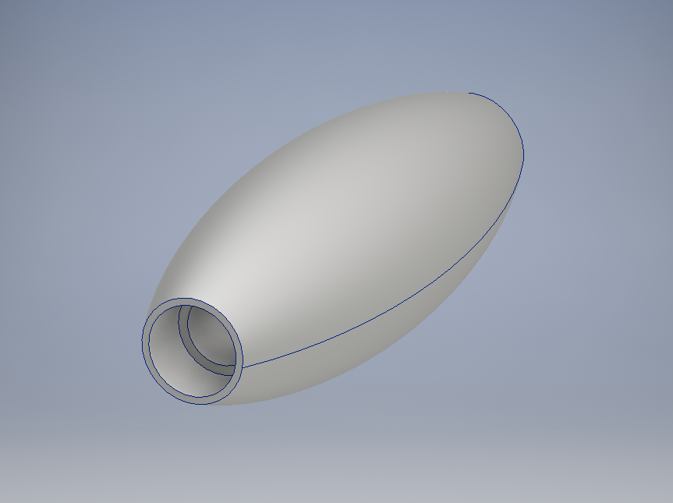With the designed shape of the roller bearing selection is important as the outer diameter is ᴓ22mm and a 3mm gap between the bearing and the outer diameter is required. This gives a maximum ᴓ19mm bearing size. The shaft diameter is 8mm, the bearing selection is shown in the calculations section. The calculation shown is for the initial scope of 500kg. The bearing selected shown in the appendix is rated to handle the load capacity NSK bearing 698 ZZ was selected, the scope was then changed by the client to 1000kg. The increased capacity created a problem as the bearings selected are not capable of handling the load required. One solution to this was to redesign the roller but quotes were obtained from State wide bearings and BSC to have the unit price of the bearings, $4.50 + GST was the best price received. It was decided to then add 2 more bearings to each roller, 4 in total as there is no available bearing that matches the require criteria. Since the additional cost of the bearings are cheaper than the cost of a total roller redesign. The final roller drawing, and design is shown in the appendix. Aluminium 6061 was the best material to use as it is lighter and cheaper than steel and posses a UTS of 300 MPa3.

Figure 1.4 Final Roller Design

### Polyurethane

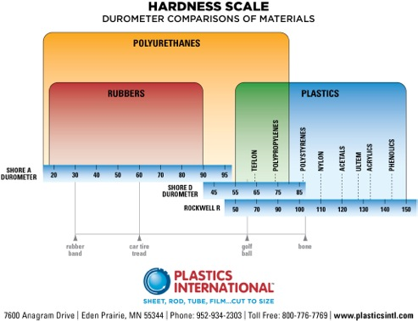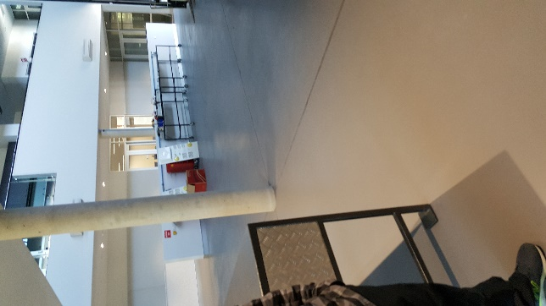The main working area for the AGV is a concrete floor shown in figure 2.1, it shows a concrete floor. As the friction between the concrete and the aluminium roller is too low, a material with a higher coefficient of friction needed to be introduced to reduce slip on the vehicle. It was decided to cast the rollers with a 5mm coating of Polyurethane to increase friction and reduce slip. The hardness of the Polyurethane is an important factor, if the deflection of the material is too high the Poly will drag and reduce the efficiency of the vehicle, and if the Poly is too hard, the friction of the wheels will be too low causing the vehicle to slip. Using figure 2.2 below a hardness of 95 on the Shore A Durometer was chosen.

Figure 2.1 Photo of main working area for AGV

Figure 2.2 Polyurethane hardness scale4

To reduce the cost of casting the rollers in Polyurethane the rollers will be given the elliptical shaping by in house machinists. By doing this the rollers will be cast in a cylindrical shape and given the final finish in house. This reduces the cost as there is no need for specific casting moulds to be manufactured.

### Frame

*Base & Lifting*

*Place content here.*

### Lifting Mechanisms

*Electro-mechanical: Gearbox, motor, ball screw, bearings, linear rail, etc.*

*Pneumatic: Compressor, receiver, air bag, etc.*

*Place content here.*

### Drive System

*Motors, Shafts, bearings, axles, pulleys, belts, brackets, etc.*

*Place content here.*

### Control System

*Motor controllers, electronics (sensors, encoders), etc.*

*Place content here.*

## Calculations

*This section should show all calculations carried out for each component as well as the operation of the platform including any FEA, shear force diagrams, bending moment diagrams, excel sheets, hand written calculations, weld calculations.*

*Eg, speeds, forces, moments, torque, deflection, etc.*

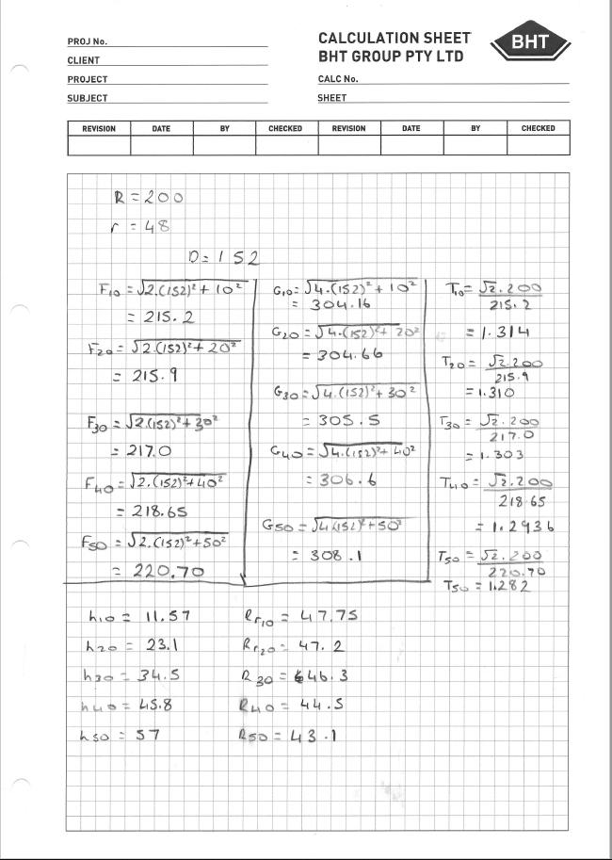*This section should also include the total weight of the platform.*

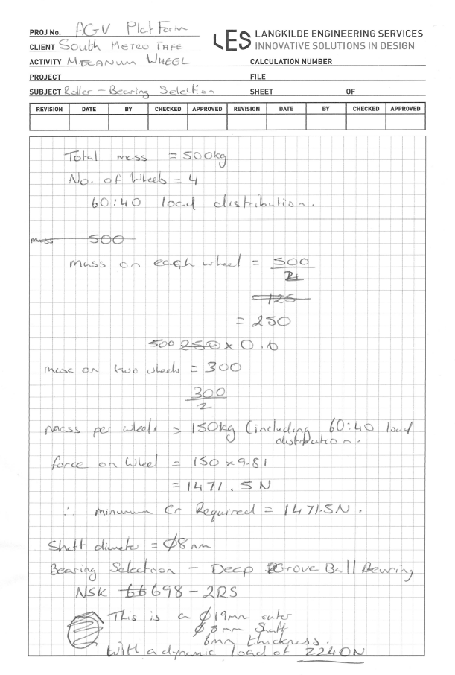

## Costings

*This section should outline all costs associated with the project. Be sure to include any quotes for materials, machining, off-the-shelf items, etc.*

The scope specified that the total cost of the project should be kept to a minimum, this played a role in the design of the vehicle. Throughout the project design concepts were presented to the project manager, quotes were obtained and if it was deemed to be too expensive other avenues were explored. For example the lifting mechanism changed from pneumatic to electro mechanical initially off the shelf screw jacks was the chosen option, the quote came back from the supplier at $1958.99 per unit with 4 required. This changed the design concept from off the shelf to a self-designed lifting mechanism to reduce the total cost.

Table 1.1 below shows the costings obtained from suppliers, the costings are not complete as there is no quotes for the electronics, screws and nuts and bolts. All obtained quotes from suppliers and email correspondence are shown in the appendix. All mild steel pricing was taken from best buy steel website5

## Discussion and Conclusion

*In this section, discuss the viability of your design in terms of the total cost involved, whether your objectives were met, client expectations, etc.*

## Recommendations

*In this section, discuss any recommendations you may have to further improve your design, manufacturing processes, materials, and handing the project over to a third party, any experience you have gain that may be beneficial, etc.*

## 

## References

1. Maps.finance.gov.au. (n.d.). [online] Available at: https://maps.finance.gov.au/sites/default/files/whs_risk_assessment_201802.pdf [Accessed 18 Aug. 2017].
2. Chiefdelphi.com. (n.d.). [online] Available at: http://www.chiefdelphi.com/media/papers/download/2749 [Accessed 25 Sep. 2017].
3. Interlloy.com.au. (n.d.). *6061 Aluminium | Interlloy | Engineering Steels + Alloys*. [online] Available at: http://www.interlloy.com.au/our-products/aluminium/6061-aluminium/ [Accessed 24 Jun. 2018].
4. Plasticsintl.com. (n.d.). *Hardness Scale - Durometer Comparisons of Materials | Plastics International*. [online] Available at: http://www.plasticsintl.com/polyhardness.htm [Accessed 24 Jun. 2018].
5. "Best Buy Steel - Discount Steel". 2018. *Bestbuysteel.Com.Au*. http://bestbuysteel.com.au/php/webstore/ecom/.

## List of Figures

## List of Tables

|  |  |
| --- | --- |
|  |  |

## Appendix



## Appendix

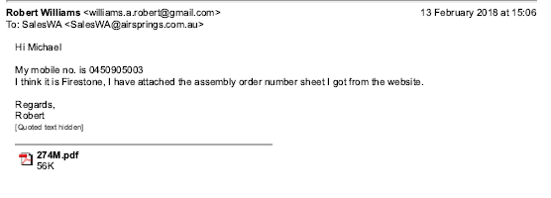

## Appendix

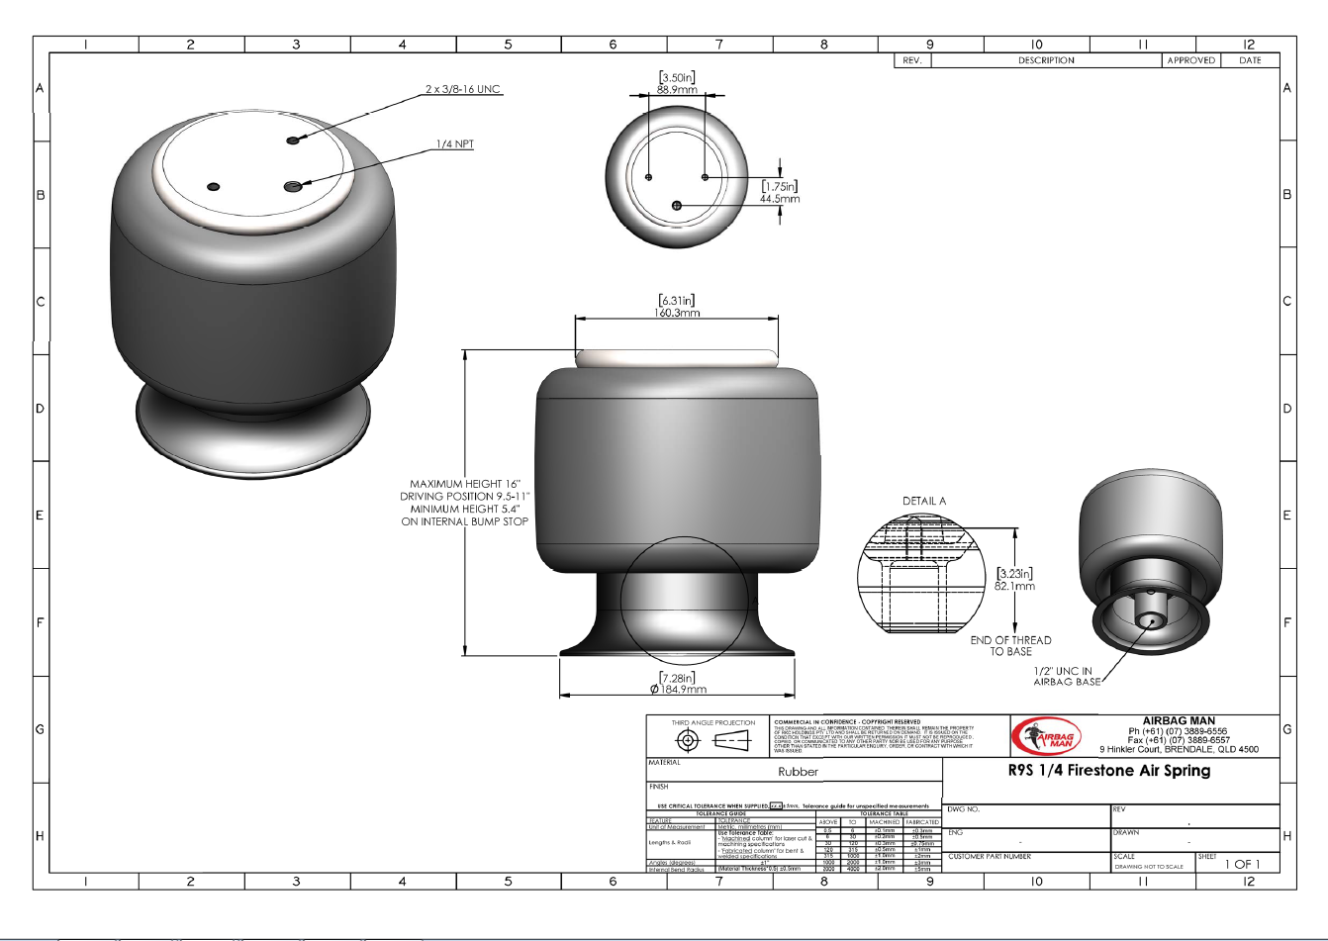

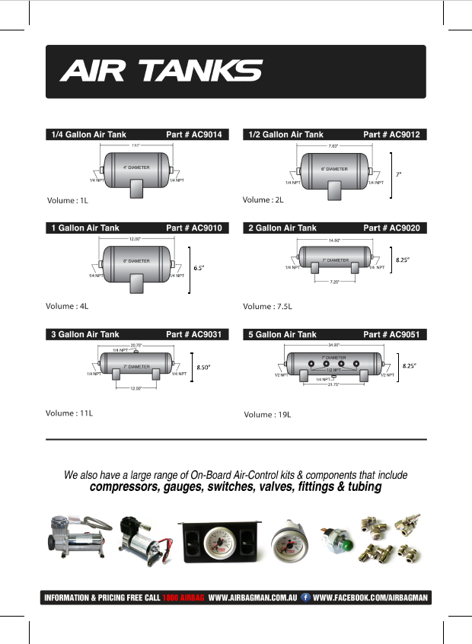

## Appendix

## Appendix

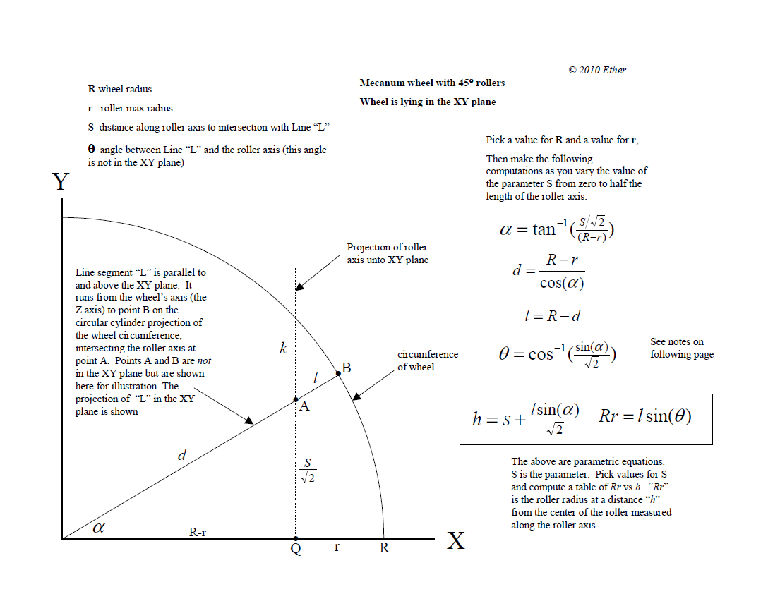

## Appendix

## Appendix

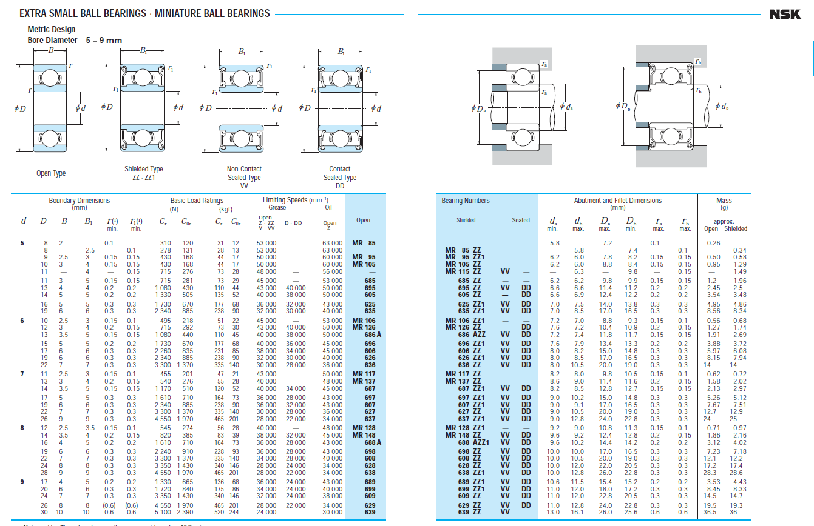

## Appendix

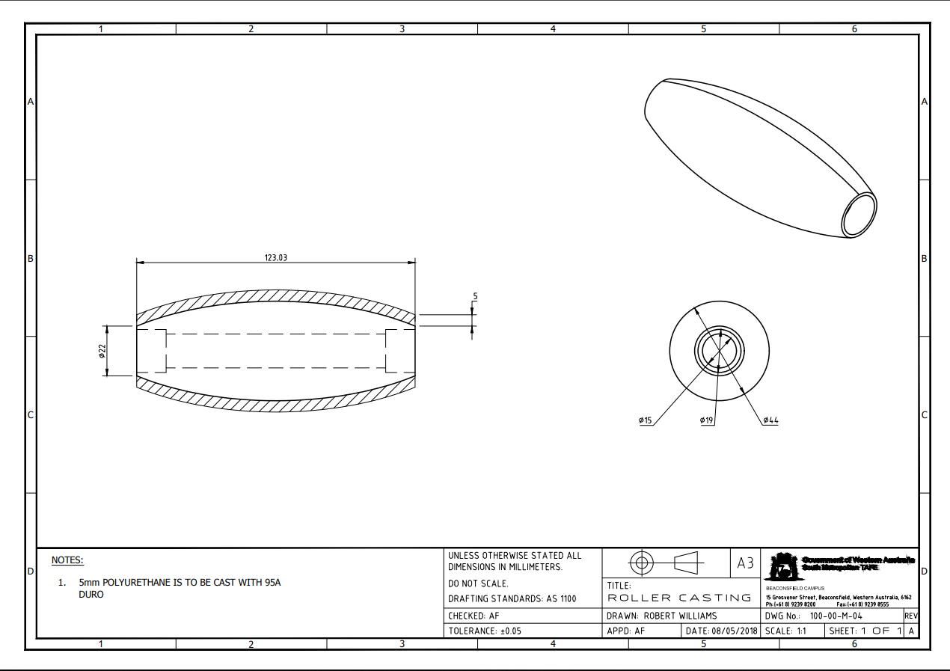

## Appendix

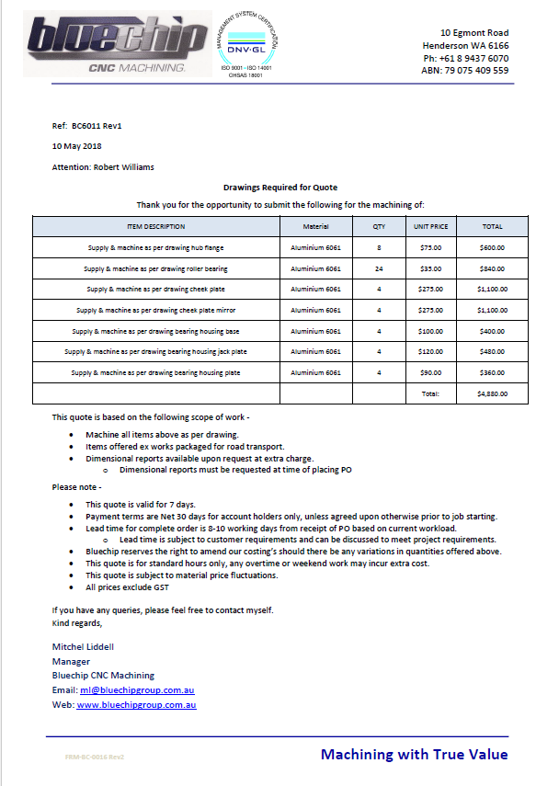

## Appendix

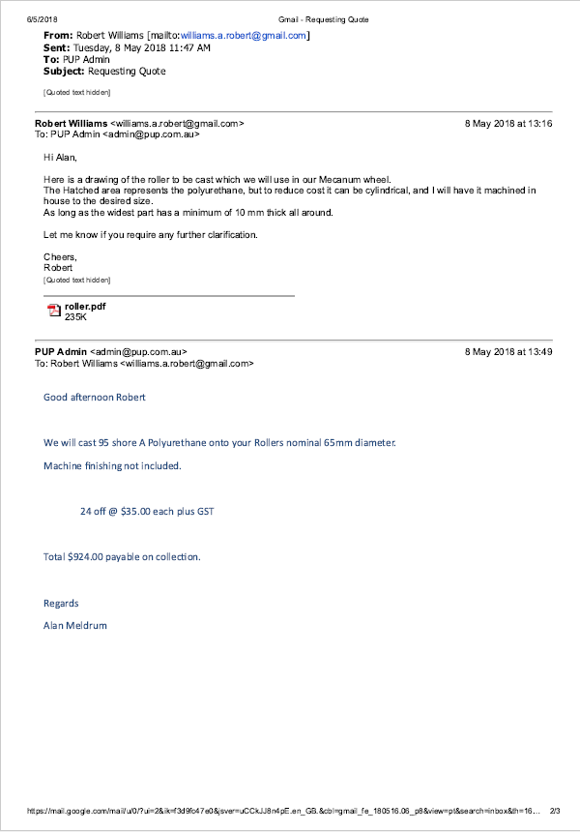

## Appendix

